Nancy E. Meade
nancyemeade@gmail.com
1
2 April 2026
Report For:
Descendants of the Francis Hutchinson family
Nancy E. Meade
Prepared by:
Subject:
William Hutchinson
Question:
Is the William Hutchinson who died in Vanderburgh County,
Indiana in 1894 the son of Francis Hutchinson and Martha
Ann (Hanna) Hutchinson of Hamilton County, Ohio?
Limitations:
Civil birth registration was not mandatory in Hamilton
County, Ohio until 1908. Federal censuses prior to 1880 do
not record relationships between household members.
Resources Used:
• Ancestry (https://www.ancestry.com/)
•
•
•
•
Newspapers.com (https://www.newspapers.com/)
FamilySearch (https://www.familysearch.org/en/)
Find A Grave (https://www.findagrave.com/)
Internet Archive (https://archive.org/)
Spelling Note:
The spellings of certain surnames and first names vary in
the historical records. For example, Bonnell, Bonnel and
Bunnel, Hutchinson, Hutcheson, and Hutchison, Hannah
and Hanna, William and Wm, have all been observed. These
variations are considered in this report.
Copyright © 2026 Nancy E. Meade | nancyemeade@gmail.com
Page 1 of 23

Report for the Francis Hutchinson Family | William Hutchinson | 12 April 2026
Table of Contents
Background Summary ..................................................................................... 3
Research Notes ................................................................................................ 3
1840 U.S. Census............................................................................................... 3
1850 U.S. Census............................................................................................... 4
1860 U.S. Census .............................................................................................. 5
Civil War ......................................................................................................... 6
Veteran Discharge Papers .................................................................................... 7
1
1
870 U.S. Census .............................................................................................. 9
880 U.S. Census ............................................................................................ 10
Will of William Hutchinson (1894)........................................................................ 10
Notable Age Discrepancies ................................................................................. 12
Conclusion .................................................................................................... 12
Further Research Suggestions.............................................................................. 12
Exhibits......................................................................................................... 13
Exhibit 1 – 1850 U.S. Census................................................................................ 13
Exhibit 2 – 1860 U.S. Census................................................................................ 14
Exhibit 3 – Civil War Roster.................................................................................. 15
Exhibit 4 – Veteran discharge Papers ..................................................................... 16
Exhibit 5 – 1870 U.S. Census................................................................................ 18
Exhibit 6 – 1880 U.S. Census................................................................................ 19
Exhibit 7a – Will of William Hutchinson (1894) pg 1..................................................... 20
Exhibit 7b – Will of William Hutchinson (1894) pg 2 .................................................... 21
Copyright © 2026 Nancy E. Meade | nancyemeade@gmail.com
Page 2 of 23

Report for the Francis Hutchinson Family | William Hutchinson | 12 April 2026
Background Summary
William Hutchinson was born about 1837 in Reading, Hamilton County, Ohio.
His age is consistently reported across census and military records but no
direct birth record exists.¹ His father, Francis Hutchinson, married Martha
Ann Hanna on 14 January 1837 in Hamilton County, Ohio. Martha died in
1849 during a cholera outbreak. In the 1850 census, one year after Martha’s
death, twelve-year-old William appears in the household of Francis Hutchinson
along with Martha’s brother, Garret Hanna. There is no other known William
Hutchinson of matching age in Reading, Hamilton County at that time.
Francis Hutchinson later remarried and had additional children with Margaret
Bowen. By 1870, Francis and Margaret were living in Boone County, Indiana,
and Francis died there in 1893.
No document explicitly names Francis and Martha as William’s parents. Their
relationship must be established through indirect evidence, primarily William’s
consistent age, shared residence in the 1850 census with his father and
maternal uncle, and the unique identifying details found across his Civil War
service, post-war residence, probate documents, and burial records.
Research Notes
1840 U.S. Census
1840 U.S. Census, Sycamore, Hamilton, Ohio
Francis Hutchinson Household
Abstract: The 1840 U.S. Census for Sycamore Township, Hamilton County,
Ohio, lists Francis Hutchinson, on the third entry on the page, as the head of a
household that includes one male aged 20–29, one female aged 20–29, and one
male under 5 years of age.²
1
“Wm. Hutchinson,” obituary, Evansville Journal (Evansville, Indiana), 24 November
1894, page 5, column 3; digital image, Newspapers.com
(https://www.newspapers.com/article/the-evansville-journal/189571192/ : accessed 25
January 2026).
2
1840 U.S. census, Hamilton County, Ohio, population schedule, Sycamore Township,
page 431(stamped), Francis Hutchinson household; digital image, Ancestry.com
https://www.ancestry.com/imageviewer/collections/8057/images/4409464_00872?pId=17195
77 : accessed 22 January 2026); citing National Archives microfilm publication M704, roll 400.
Copyright © 2026 Nancy E. Meade | nancyemeade@gmail.com
Page 3 of 23

Report for the Francis Hutchinson Family | William Hutchinson | 12 April 2026
Analysis: This record establishes that Francis Hutchinson was maintaining a
household in the correct township three years after his marriage to Martha
Ann Hanna (1837). The presence of the male child "under 5 years of age" is
the earliest evidence of a son and is chronologically consistent with the birth
of William Hutchinson (c. 1837), whose identity is supported by subsequent
census, military, and probate records.
1850 U.S. Census
1850 U.S. Census, Sycamore, Hamilton, Ohio
Garret V. Hannah Household (See EXHIBIT 1.)
Name
Age
Gender Occupation
Birthplace
Garret V Hannah
Cordelia Hannah
Laura M Hannah
Mary F Hannah
Corah B Hannah
Francis Hutchinson
Wm Hutchinson
39
38
14
10
7
M
F
Shoe Maker
Ohio
New York
Ohio
F
F
Ohio
F
New Jersey
Ohio
36
12
M
M
Teamster
New Jersey
Abstract: The 1850 U.S. Census enumerates the household of Garret V. Hannah
in Sycamore Township, Hamilton County, Ohio, recorded on 23 September
1850.³ The household consists of Garret V. Hannah, age 39; Cordelia Hannah,
age 38; Laura M. Hannah, age 14; Mary F. Hannah, age 10; and Corah B.
Hannah, age 7. Also present in the household are Francis Hutchinson, age 36,
occupation teamster, and William Hutchinson, age 12. Birthplaces reported
include Ohio, New York, and New Jersey. Relationships are not stated in this
census.
3
1850 U.S. census, Hamilton County, Ohio, population schedule, Sycamore
Township, page 415a (stamped), dwell. 570, fam. 587, Garret V Hannah household, line 20;
William Hutchinson entry, line 26; digital image, Ancestry.com
(https://www.ancestry.com/imageviewer/collections/8054/images/4204443_00351?pId=159
1
0341 : accessed 6 December 2025); citing National Archives microfilm publication M432,
roll 686.
Copyright © 2026 Nancy E. Meade | nancyemeade@gmail.com
Page 4 of 23
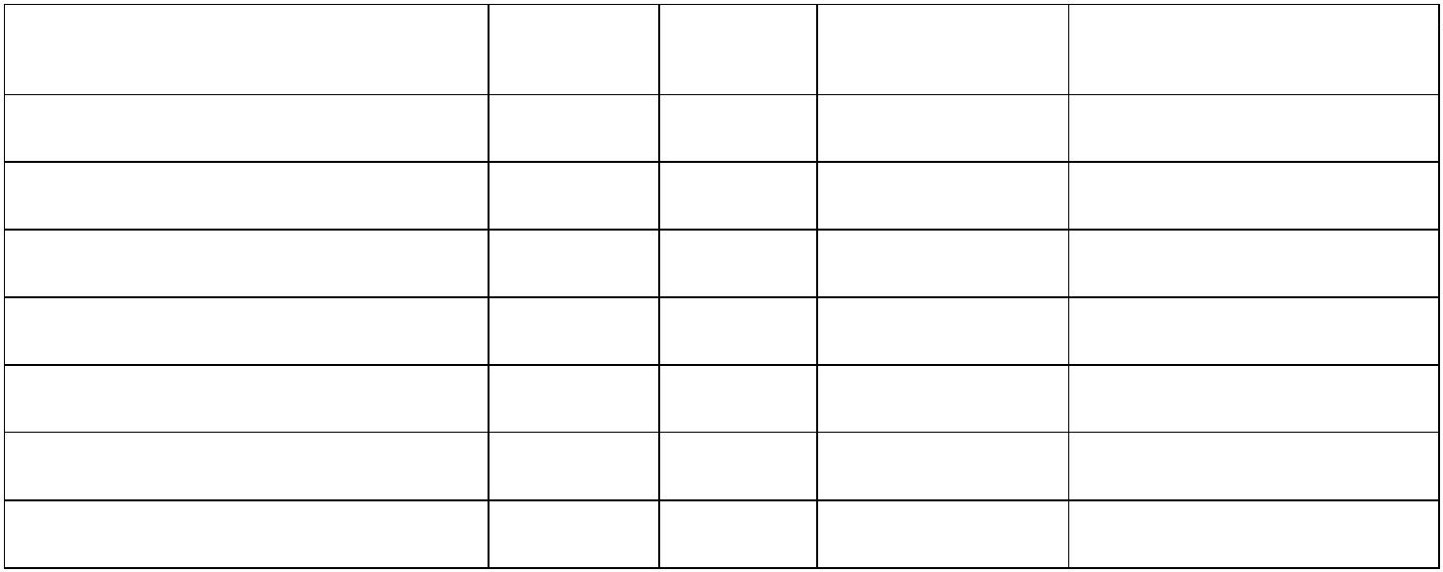

Report for the Francis Hutchinson Family | William Hutchinson | 12 April 2026
Analysis: Garret Hannah is identified as the brother of Martha Ann Hanna
(relationship established in separate documentation), Francis’s first wife, who
died the previous year in July 1849 of cholera. Although the census does not
state relationships, this record provides indirect evidence of parentage: the
presence of Francis, a widower living with his deceased wife's brother, and a
presumed child of the correct age, provides strong evidence that William
Hutchinson is the son of Martha Ann Hanna and Francis Hutchinson. This is
the earliest record located to date that names William, and it places him
within the immediate family network of Martha Ann (Hanna) Hutchinson’s
relatives.
It is notable that the 1850 census reports William Hutchinson’s birthplace as
New Jersey, creating a conflict with later records. However, all subsequent
evidence, including the 1860, 1870, and 1880 censuses, his Civil War
discharge papers, and his obituary, consistently identifies his birthplace as
Ohio, with the obituary specifying Reading, Ohio. Given the consistency of
these later records and William’s repeated association with Reading and
nearby Sycamore Township in Hamilton County, Ohio, the weight of the
evidence supports Ohio as William Hutchinson’s place of birth.
1860 U.S. Census
1860 U.S. Census, Sycamore, Hamilton, Ohio
Voorhis and Solsman Households (See EXHIBIT 2.)
Name
Age
Sex
Occupation
Birthplace
Garratt Voorhis
97
M
Retired Farmer
New Jersey
Name
Age
20
Sex
M
Occupation
Farmer
Birthplace
Ohio
Phillip Solsman
W Hutchinson
22
M
Farm Hand
Ohio
Abstract: The 1860 U.S. Census for Sycamore Township, Hamilton County,
Ohio, enumerated on 21 June 1860, lists William Hutchinson, age 22, born
in Ohio, residing as a farm hand in the household of Phillip Solsman, age 20,
a farmer. The adjacent household is that of Garrett Voorhis, age 97, a retired
Copyright © 2026 Nancy E. Meade | nancyemeade@gmail.com
Page 5 of 23
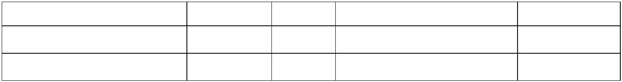

Report for the Francis Hutchinson Family | William Hutchinson | 12 April 2026
farmer.⁴ The census provides no stated relationship between William
Hutchinson and the head of household.
Analysis: The close proximity of William Hutchinson’s residence to that of
Garratt Voorhis, his maternal great-grandfather, places William within his
maternal family’s geographic and social network ten years after his
appearance in the 1850 census household of Garret V. Hannah, Garratt
Voorhis’ grandson. This continuity of location and age supports the conclusion
that the William Hutchinson enumerated in 1860 is the same individual
previously identified in Hamilton County and establishes his presence there
immediately prior to his Civil War enlistment in 1861.
Civil War
Civil War Service: Enlistment and Associative Evidence (See EXHIBIT 3.)
Abstract: The roster for Company D of the 4th Regiment Ohio Veteran Volunteer
Cavalry states the company "Mustered in November 25, 1861, at Camp
Dennison, Ohio.”⁵ The list of soldiers confirms the enlistment of three key
individuals on or around that date:
Name
Rank
Bugler
Private
Farrier
Age
24
Enroll Date
25 Nov 1861
25 Nov 1861
23 Nov 1861
Time
William Hutchinson
Warren Bonnell
Henry P. Bowen
3 years
3 years
3 years
21
28
Analysis: This enlistment roster provides critical evidence linking William
Hutchinson’s pre-war residence in Hamilton County, Ohio to his post-war
settlement in Vanderburgh County, Indiana. The enlistment of William Hutchinson
with Henry P. Bowen and Warren Bonnell establishes three independent but
reinforcing connections:
4
1860 U.S. census, Hamilton County, Ohio, population schedule, Sycamore Township,
page 239 (stamped), dwell. 463, fam. 469, Phillip Solsman household, line 15; William
Hutchinson entry, line 21; digital image, Ancestry.com
(https://www.ancestry.com/imageviewer/collections/7667/images/4282581_00073?ssrc=pt&t
reeid=64301995&personid=152045248974&usePUB=true&pId=43465310 : accessed 22
January 2026); citing National Archives microfilm publication M653, roll 981.
5
Lucien Wulsin, The Story of the Fourth Regiment Ohio Veteran Volunteer Cavalry
(Cincinnati: s.n., 1912), 175; digital images, Internet Archive
(https://archive.org/details/cu31924030913564 : accessed 22 January 2026).
Copyright © 2026 Nancy E. Meade | nancyemeade@gmail.com
Page 6 of 23


Report for the Francis Hutchinson Family | William Hutchinson | 12 April 2026
1. Paternal Step-Family Connection (Bowen):
William Hutchinson’s enlistment on 25 November 1861 alongside Henry
P. Bowen (enlisted 23 November 1861) places him in direct association
with the Bowen family of his stepmother, Margaret Bowen Hutchinson.
Henry P. Bowen was the brother of Margaret Bowen Hutchinson, the
second wife of Francis Hutchinson. This association provides strong
indirect evidence that William maintained ties to his father’s household
following Francis Hutchinson’s remarriage.
2. Post-War Residential Association (Bonnell):
The simultaneous enlistment of William Hutchinson and Warren Bonnell
establishes a military bond between two men who later appear together
in Vanderburgh County, Indiana. This wartime association explains
William Hutchinson’s post-war relocation to Evansville where he is
consistently associated with Bonnell in later records rather than
relocating with his father to Boone County, Indiana.
3. Chronological Identity Consistency:
William Hutchinson’s reported age of 24 at enlistment in November 1861
is chronologically consistent with the William Hutchinson enumerated
as age 22 in the 1860 census and with his honorable discharge in 1864.
This continuity confirms that the soldier, the pre-war civilian, and the
post-war resident are the same individual.
Together, these associations link the son of Francis and Martha
Hutchinson to a specific social and military network that helps explain his
post-war residence and later life in Indiana.
Veteran Discharge Papers
Civil War Service: Discharge of William Hutchinson (See EXHIBIT 4.)
This document features the military discharge certificate for William
Hutchinson, age twenty-four in 1864, who served as a bugler in Captain P. H.
Copyright © 2026 Nancy E. Meade | nancyemeade@gmail.com
Page 7 of 23

Report for the Francis Hutchinson Family | William Hutchinson | 12 April 2026
Warner’s Company D, 4th Regiment of Ohio Volunteer Cavalry.⁶ The certificate
states that William Hutchinson enlisted on 25 November 1861 for a three-year
term and was discharged on 25 November 1864 at Louisville, Kentucky due to
expiration of his term of service. It identifies him as born in Hamilton County,
Ohio; five feet six inches tall; fair complexioned; with blue eyes and brown hair;
and employed as a broom maker at the time of enlistment. The discharge is
signed by adjutant Osmond A. Smith and mustering officer Captain L. M.
Hosea, dated 25 November 1864.
A separate Oath of Identity section, sworn on 24 December 1866 in Cincinnati,
Ohio, and signed by Hutchinson further identifies him as the same man who
served in Company D of the 4th Ohio Cavalry and was discharged due to
expiration of his term of service recorded in this later document as Columbia,
Tennessee.
Analysis: This discharge certificate is a derivative source that provides primary
evidence for key facts about William Hutchinson’s military service and personal
description. The document establishes that a man named William Hutchinson,
born in Hamilton County, Ohio, served in Company D of the 4th Ohio Cavalry and
was discharged in November 1864 at the expiration of his term of service.
The stated birthplace, Hamilton County, Ohio, is consistent with the William
Hutchinson who appears in the 1850 Sycamore Township household with Francis
Hutchinson and Garret V. Hannah. The discharge certificate records William’s age
as twenty-four. This same age appears in his enlistment record three years
earlier which may reflect a clerical carry-forward on the discharge document
rather than the correct age at the time of discharge. His age at the time of
enrollment remains consistent with William’s reported age in the 1850 census.
The record of his honorable service in the 4th Ohio Cavalry later provided the
basis for his federal pension application which further anchors his identity across
multiple jurisdictions. This document helps link the William Hutchinson of
Hamilton County to the military service later corroborated by Evansville, Indiana
records, pension index cards, and ultimately his 1894 probate in Indiana.
6
Hamilton County, Ohio, Recorder’s Office, Veteran Discharge Books,1 & 2 (1862-1918),
Volume MILD01; digital image, FamilySearch
(https://www.familysearch.org/ark:/61903/3:1:3QS7-892F-T577 : accessed 7 December 2025);
entry for William Hutchinson, image 452 of 626.
Copyright © 2026 Nancy E. Meade | nancyemeade@gmail.com
Page 8 of 23

Report for the Francis Hutchinson Family | William Hutchinson | 12 April 2026
1870 U.S. Census
1870 U.S. Census, Evansville, Vanderburgh, Indiana
Bonnell Household (See EXHIBIT 5.)
Abstract: The 1870 U.S. Census for Evansville Township, Vanderburgh County,
Indiana, enumerated on 24 June 1870, records William Hutchinson, age 32,
born in Ohio, residing in the household of Warren Bonnell.⁷ Warren Bonnell,
age 29, born in Ohio, is listed as head of household, with his wife and children
also present. William Hutchinson is listed within the same dwelling, with his
occupation recorded as laborer. No relationship between William Hutchinson
and the head of household is stated.
Analysis: This 1870 census entry places William Hutchinson in Evansville
Township, Vanderburgh County, Indiana, residing in the household of Warren
Bonnell, a known associate who appears repeatedly with William in military,
residential, and later documentary records. William’s reported age (32) and Ohio
birthplace are consistent with earlier census and military records identifying him
as the William Hutchinson born in Ohio in the late 1830s. Although no
relationship is stated, the shared dwelling with Bonnell reflects a continued
association that is documented both before and after this census enumeration.
The census provides continuity of identity by placing William Hutchinson in
Evansville by 1870, aligning with later city directory listings, newspaper notices,
and probate records in Vanderburgh County. His presence in Bonnell’s household
supports the conclusion that the William Hutchinson enumerated here is the same
individual previously identified in Hamilton County, Ohio, and later documented
in Indiana records through the end of his life.
7
1870 U.S. census, Vanderburgh County, Indiana, population schedule, Center
Township, page 106A (stamped), dwelling 2, family 2, household of Warren Bunnel, William
Hutchinson entry, line 12; digital image, Ancestry.com
(https://www.ancestry.com/imageviewer/collections/7163/images/4263251_00039?pId=1811
9
3
762 : accessed 26 January 2026); citing National Archives microfilm publication M593, roll
64.
Copyright © 2026 Nancy E. Meade | nancyemeade@gmail.com
Page 9 of 23

Report for the Francis Hutchinson Family | William Hutchinson | 12 April 2026
1880 U.S. Census
1880 U.S. Census, Center, Vanderburgh, Indiana
Bonnell Household (See EXHIBIT 6.)
Abstract: The 1880 U.S. Census for Center Township, Vanderburgh County,
Indiana, enumerated on 22 June 1880, lists William Hutchinson residing in
dwelling 341 in the household headed by Warren Bonnell.⁸ William is recorded
as a 42-year-old male, born in Ohio, with his relationship to the head of
household stated as partner and his occupation listed as dairyman.
Analysis: This census entry places William Hutchinson in the household of
Warren Bonnell in Center Township, Vanderburgh County, Indiana and explicitly
identifies his relationship to the head of household as partner. While the census
does not define the nature of that partnership, the term indicates an occupational
arrangement rather than a familial relationship. William’s occupation as
dairyman further supports a working partnership connected to dairy operations
with Bonnell.
William’s reported birthplace as Ohio is consistent with earlier and later records
and his age aligns reasonably with the William Hutchinson previously identified
in the 1850 and 1860 censuses in Hamilton County, Ohio and in the 1870 census
in Vanderburgh County, Indiana. The identification of William as a partner in this
household strengthens the link between William Hutchinson and Warren Bonnell,
demonstrating an economic and residential association extending at least into
1880.
This record provides strong indirect evidence of identity continuity, showing that
William Hutchinson remained in Vanderburgh County for an extended period
following the Civil War and was socially and economically integrated with the
Bonnell household. When considered alongside earlier census records, military
service, and later probate evidence, this entry supports the conclusion that the
William Hutchinson enumerated here is the same individual who appears in
earlier Ohio records and who died in Vanderburgh County in 1894.
8
1880 U.S. census, Vanderburgh County, Indiana, population schedule, Center
Township, Enumeration District 069, page 138A (stamped), dwelling 341, household of Warren
Bonnel; William Hutchinson entry, line 30; digital image, Ancestry
(https://www.ancestry.com/imageviewer/collections/6742/images/4240657-
00284?pId=27758994 : accessed 26 January 2026); citing Tenth Census of the United States,
1880, National Archives microfilm publication T9, roll 316.
Copyright © 2026 Nancy E. Meade | nancyemeade@gmail.com
Page 10 of 23

Report for the Francis Hutchinson Family | William Hutchinson | 12 April 2026
Will of William Hutchinson (1894)
Probate of William Hutchinson, Vanderburgh County, Indiana (See
EXHIBIT 7.)
Abstract: The will of William Hutchinson dated 2 August 1894 and probated in
Vanderburgh County, Indiana identifies him as an unmarried resident of
Vanderburgh County, Indiana in feeble health but of sound mind.⁹ The will
directs payment of debts and funeral expenses, provides for the erection of a
tombstone, and makes specific bequests to Warren Bonnell, including
forgiveness of a $175 debt and four cows. The remainder of the estate is
bequeathed to his stepmother, Margaret Hutchinson of Boone County, Indiana.
Warren Bonnell is named executor without bond. The will was witnessed by
John Junker Sr. and Charles S. Martin and was admitted to probate in
November 1894.
Analysis: This will is an original source providing primary evidence of William
Hutchinson’s residence, marital status, relationships, and estate arrangements at
the end of his life. It establishes that William was unmarried in 1894 and resided
in Vanderburgh County, Indiana. The appointment of Warren Bonnell as executor,
along with the bequests made to him, demonstrates a close and trusted
relationship that is consistent with William’s long-term residence in the Bonnell
household as documented in the 1870 and 1880 censuses.
The bequest of the residue of the estate to William’s stepmother, Margaret
Hutchinson of Boone County, Indiana, provides direct evidence of the continued
existence of this step-relationship and confirms that William recognized her as his
next of kin for inheritance purposes. It also provides indirect evidence that this
step-relationship was formed through his father, consistent with earlier records
identifying Francis Hutchinson as William’s parent. The will further supports
continuity of identity by linking the William Hutchinson of Vanderburgh County
with the same individual documented in earlier census, military, and obituary
records.
9
William Hutchinson will (1894), Vanderburgh County, Indiana, Will Records, vol. F–H,
1892–1902; pages 65–66; will dated 2 August 1894, probated November 1894; digital image,
Ancestry.com (Indiana, U.S., Wills and Probate Records, 1798–1999,
https://www.ancestry.com/imageviewer/collections/9045/images/1479643-
00199?pId=1550247 : accessed 26 January 2026); citing original records of Indiana county,
district, and probate courts.
Copyright © 2026 Nancy E. Meade | nancyemeade@gmail.com
Page 11 of 23

Report for the Francis Hutchinson Family | William Hutchinson | 12 April 2026
The specificity of the bequests, the identification of named associates, and the
probate proceedings shortly after his death anchor William Hutchinson firmly in
Vanderburgh County in 1894 and contribute to the overall body of evidence
establishing the life course of the same man identified earlier in Hamilton County,
Ohio.
Notable Age Discrepancies
Age discrepancies appear across the records examined in this report. Most birth
information is recorded later in life, often decades after the event, and may
reflect memory, informant knowledge, or clerical practice rather than a record at
the time. For example, the photo of William Hutchinson’s grave marker, as
documented on his Find A Grave memorial, records his lifespan as 1839–
1894.¹⁰ Because the marker was created after his death and the informant is
unknown, it represents later secondary information and is therefore less reliable
for precise birth dating than records created closer to the time of birth. These
variations are considered in this report.
Conclusion
Although no record explicitly names William Hutchinson’s parents, the weight of
evidence supports that he was the son of Francis Hutchinson and Martha
Hanna of Hamilton County, Ohio. In 1850, William appears in the household of
his maternal uncle, Garret Hannah, where his father, Francis Hutchinson, is
also residing; later records show continuity through Civil War service; long-term
residence in Indiana; and multiple census entries. William’s 1894 will naming
his stepmother, Margaret Hutchinson, Francis’s second wife, further links him
to Francis’s family and answers the research question.
Further Research Suggestions
Potential research suggestions include locating church baptismal records for
William Hutchinson in Hamilton County, Ohio; examining land or guardianship
records following Martha Hanna Hutchinson’s death in 1849; and conducting a
more comprehensive review of probate or estate-related documents in Boone
County, Indiana associated with Francis Hutchinson that may identify heirs or
name William directly.
1
⁰ Find a Grave, database and images
(https://www.findagrave.com/memorial/108807088/william-hutchinson : accessed 26
January 2026), memorial for William Hutchinson (1839–1894), Memorial ID 108807088;
citing Locust Hill Cemetery, Evansville, Vanderburgh County, Indiana; memorial
maintained by Nancy Meade (contributor 48319629).
Copyright © 2026 Nancy E. Meade | nancyemeade@gmail.com
Page 12 of 23

Report for the Francis Hutchinson Family | William Hutchinson | 12 April 2026
Exhibits
Exhibit 1 – 1850 U.S. Census
1
4
850 U.S. census, Hamilton County, Ohio, population schedule, Sycamore Township, page
15a (stamped), dwell. 570, fam. 587, Garret V Hannah household, line 20; William Hutchinson
entry, line 26; digital image, Ancestry.com
(https://www.ancestry.com/imageviewer/collections/8054/images/4204443_00351?pId=1591
0
6
341 : accessed 6 December 2025); citing National Archives microfilm publication M432, roll
86.
Copyright © 2026 Nancy E. Meade | nancyemeade@gmail.com
Page 13 of 23
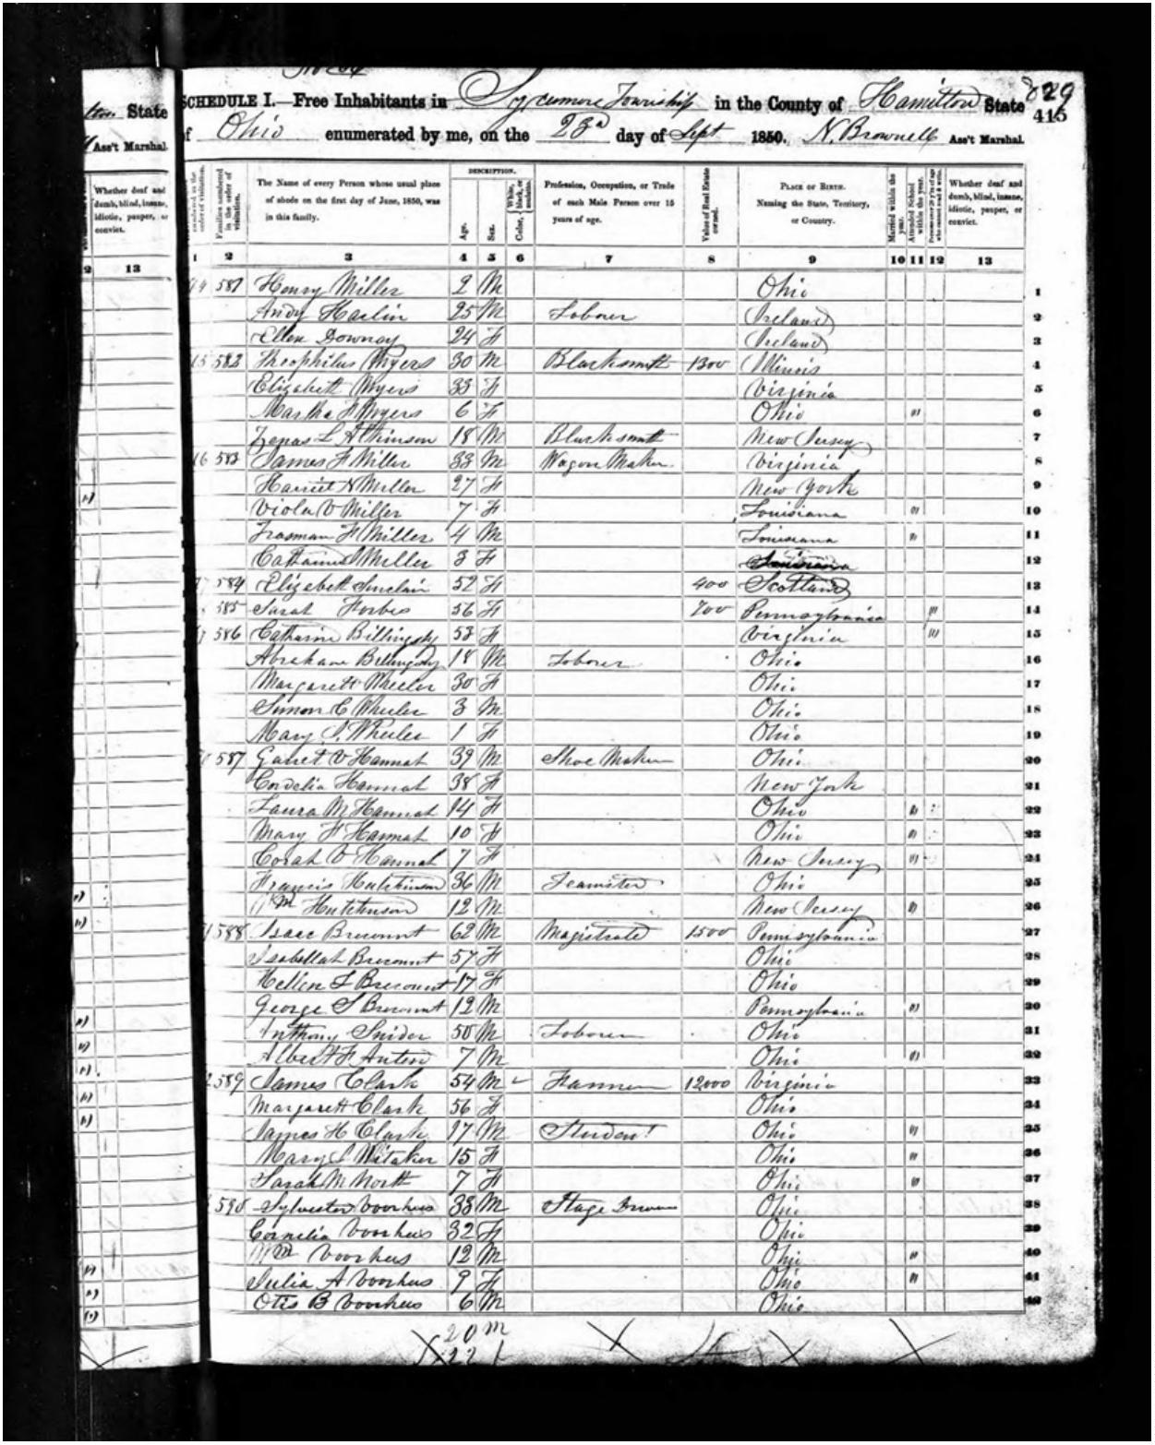

Report for the Francis Hutchinson Family | William Hutchinson | 12 April 2026
Exhibit 2 – 1860 U.S. Census
1860 U.S. census, Hamilton County, Ohio, population schedule, Sycamore Township, page 239
(stamped), dwell. 463, fam. 469, Phillip Solsman household, line 15; William Hutchinson entry,
line 21; digital image, Ancestry.com
(https://www.ancestry.com/imageviewer/collections/7667/images/4282581_00073?ssrc=pt&t
reeid=64301995&personid=152045248974&usePUB=true&pId=43465310 : accessed 22
January 2026); citing National Archives microfilm publication M653, roll 981.
Copyright © 2026 Nancy E. Meade | nancyemeade@gmail.com
Page 14 of 23
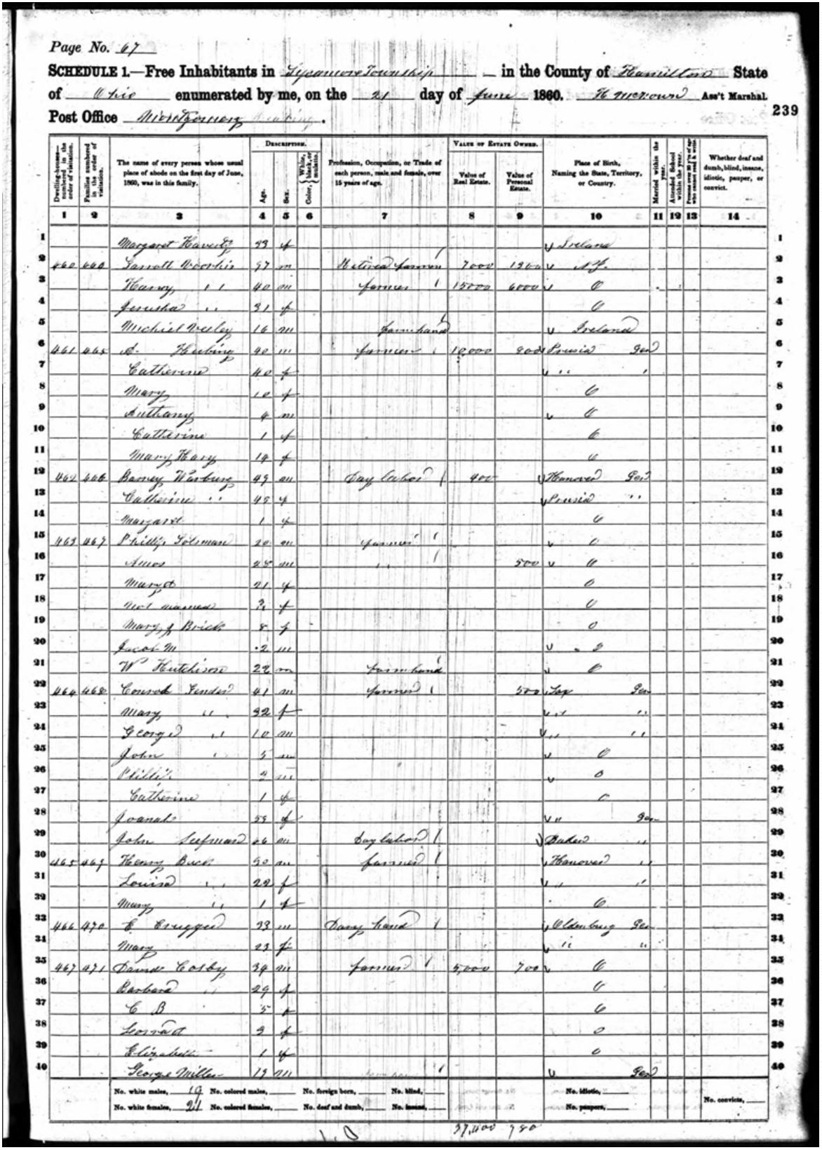

Report for the Francis Hutchinson Family | William Hutchinson | 12 April 2026
Exhibit 3 – Civil War Roster
Lucien Wulsin, The Story of the Fourth Regiment Ohio Veteran Volunteer Cavalry (Cincinnati:
s.n., 1912), 175; digital images, Internet Archive
(https://archive.org/details/cu31924030913564 : accessed 22 January 2026).
Copyright © 2026 Nancy E. Meade | nancyemeade@gmail.com
Page 15 of 23
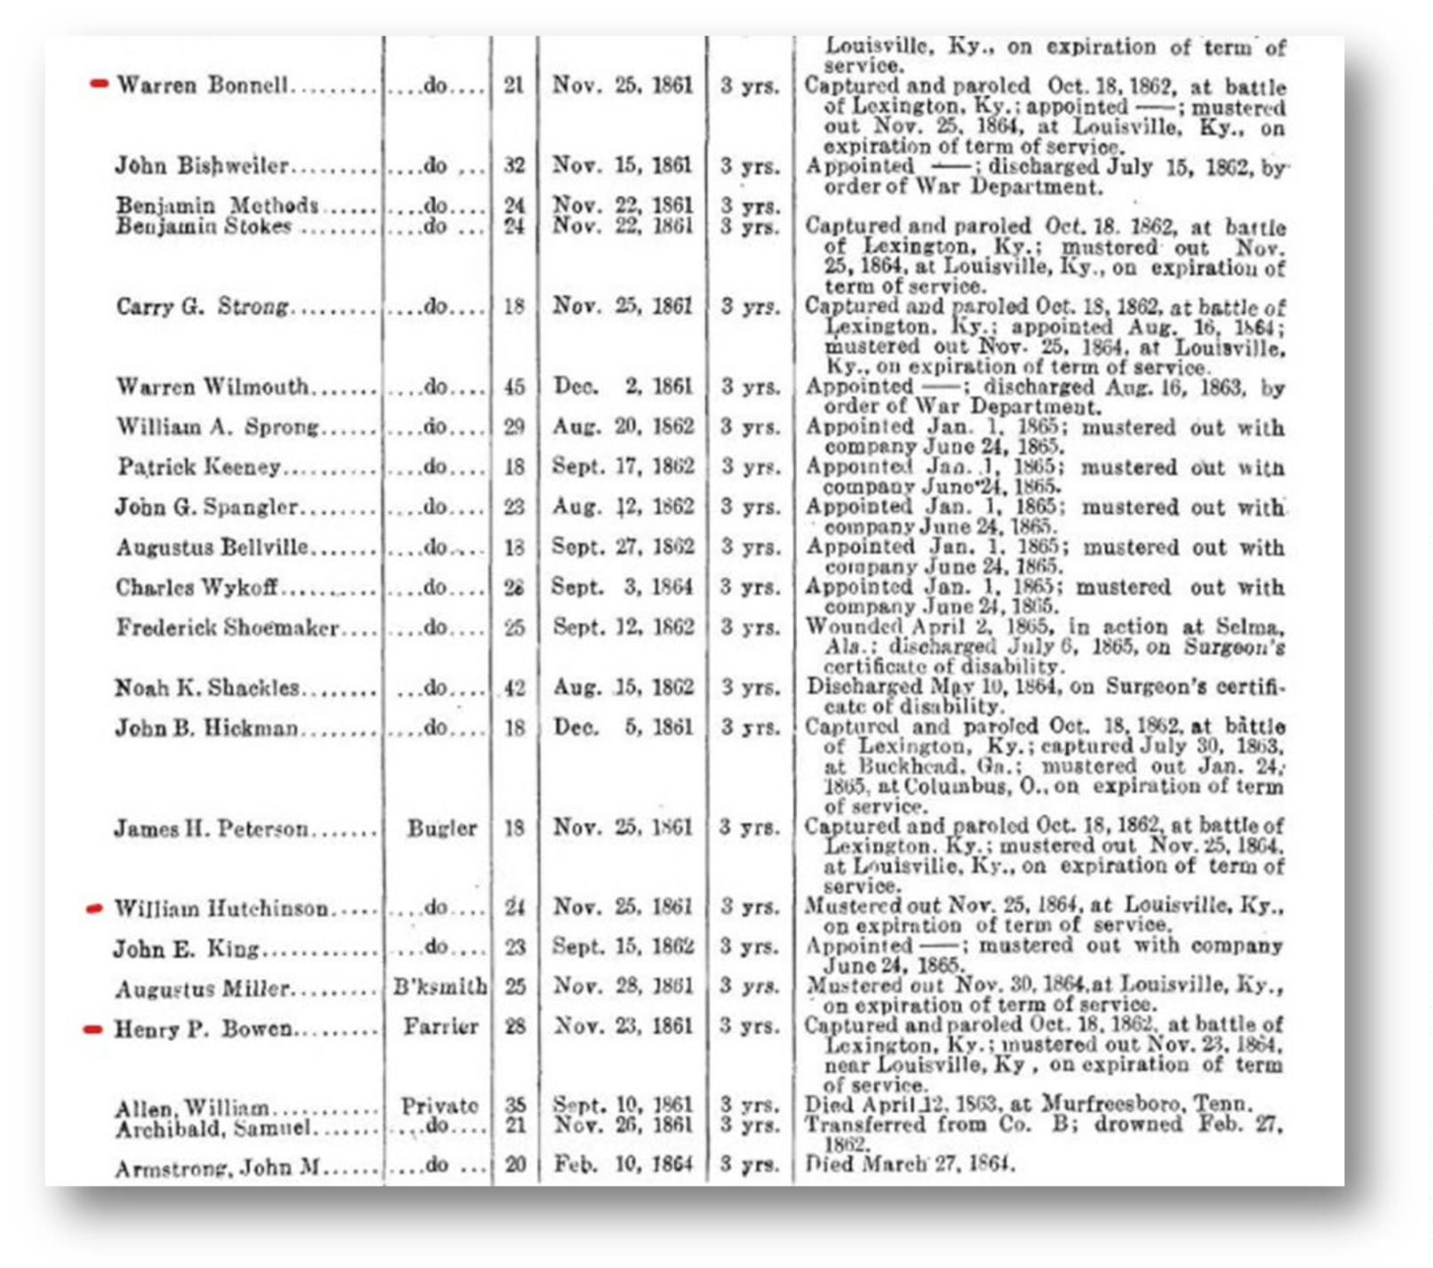

Report for the Francis Hutchinson Family | William Hutchinson | 12 April 2026
Exhibit 4 – Veteran Discharge Papers
Hamilton County, Ohio, Recorder’s Office, Veteran Discharge Books,1 & 2 (1862-1918), Volume
MILD01; digital image, FamilySearch (https://www.familysearch.org/ark:/61903/3:1:3QS7-
892F-T577 : accessed 7 December 2025); entry for William Hutchinson, image 452 of 626.
Copyright © 2026 Nancy E. Meade | nancyemeade@gmail.com
Page 16 of 23
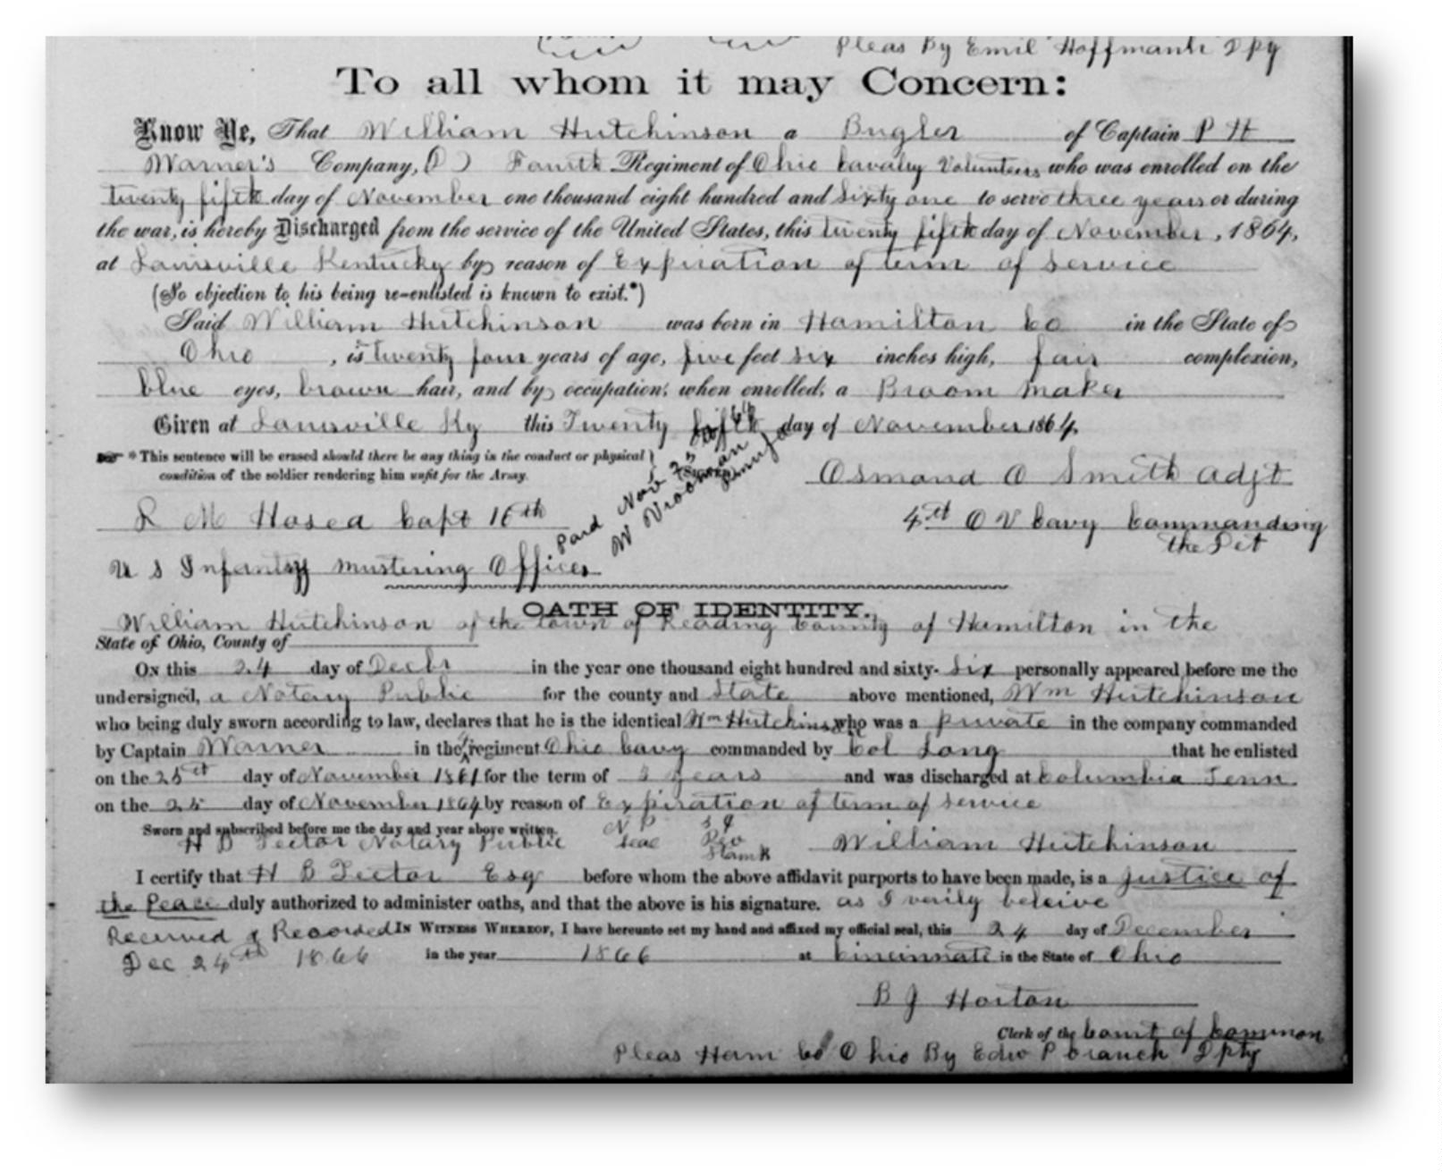

Report for the Francis Hutchinson Family | William Hutchinson | 12 April 2026
Transcription of Discharge Papers
To all whom it may Concern:
Know Ye, That William Hutchinson a Bugler of Captain PH Warner’s Company,
D Fourth Regiment of Ohio Cavalry Volunteers who was enrolled on the twenty
fifth day of November on thousand eight hundred and sixty one to serve three
years or during the war, is hereby Discharged from the service of the United
States, this twenty fifth day of November, 1864, at Louisville Kentucky by
reason of Expiration of term of service.
Said William Hutchinson was born in Hamilton County in the State of Ohio, is
twenty four years of age five feet six inches high, fair complexion, blue eyes,
brown hair, and by occupation, when enrolled, a broom maker.
Given at Louisville Kentucky this twenty fifth day of November 1864.
Osmond A Smith adjt
4th OV Cavalry Commanding Det
L M Hasea or Hosea Capt 16th US Infantry Mustering Office
Oath of Identity
William Hutchinson of the Town of Reading, County of Hamilton in the State of
Ohio.
On this 24th day of December in the year one thousand eight hundred and
sixty-six personally appeared before me the undersigned, a Notary Public for the
county and State above mentioned, Wm Hutchinson who being duly sworn
according to law, declares that he is the identical Wm Hutchinson who was a
private in the company commanded by Captain Warner in the 4th regiment Ohio
Cavalry commanded by Col. Lang. That he enlisted on the 25th day of November
1
861 for the term of 3 years and was discharged at Columbia, Tennessee on
5th day of November 1864 by reason of expiration of term of service.
2
Sworn and subscribed before me the day and year above written.
I certify that H B Lector Esq before who the affidavit purports to have been
made, is a Justice of the Peace duly authorized to administer oaths, and that
the above is his signature. As I verily believe. In witness, whereof, I have
hereunto set my hand and affixed my official seal, this 24th day of December in
the year 1866 at Cincinnati in the State of Ohio.
B J Horton Clerk of the Court of Common Pleas Ham Co
1
his By Edw P branch Dpty
Copyright © 2026 Nancy E. Meade | nancyemeade@gmail.com
Page 17 of 23

Report for the Francis Hutchinson Family | William Hutchinson | 12 April 2026
Exhibit 5 – 1870 U.S. Census
1
1
870 U.S. census, Vanderburgh County, Indiana, population schedule, Center Township, page
06A (stamped), dwelling 2, family 2, household of Warren Bunnel, William Hutchinson entry,
line 12; digital image, Ancestry.com
(https://www.ancestry.com/imageviewer/collections/7163/images/4263251_00039?pId=1811
9
3
762 : accessed 26 January 2026); citing National Archives microfilm publication M593, roll
64.
Copyright © 2026 Nancy E. Meade | nancyemeade@gmail.com
Page 18 of 23
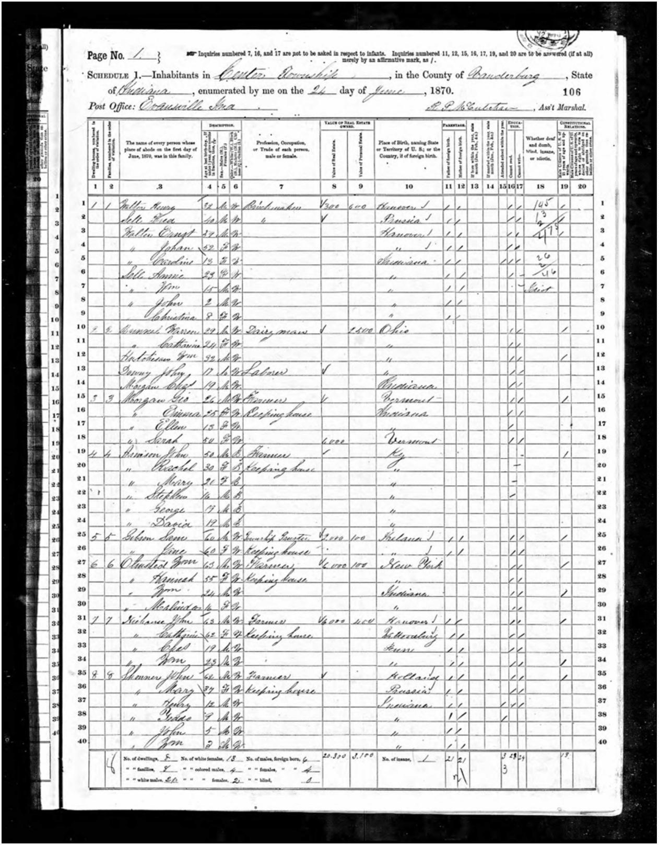

Report for the Francis Hutchinson Family | William Hutchinson | 12 April 2026
Exhibit 6 – 1880 U.S. Census
1880 U.S. census, Vanderburgh County, Indiana, population schedule, Center Township,
Enumeration District 069, page 138A (stamped), dwelling 341, household of Warren Bonnel;
William Hutchinson entry, line 30; digital image, Ancestry
(https://www.ancestry.com/imageviewer/collections/6742/images/4240657-
00284?pId=27758994 : accessed 26 January 2026); citing Tenth Census of the United States,
1880, National Archives microfilm publication T9, roll 316.
Copyright © 2026 Nancy E. Meade | nancyemeade@gmail.com
Page 19 of 23
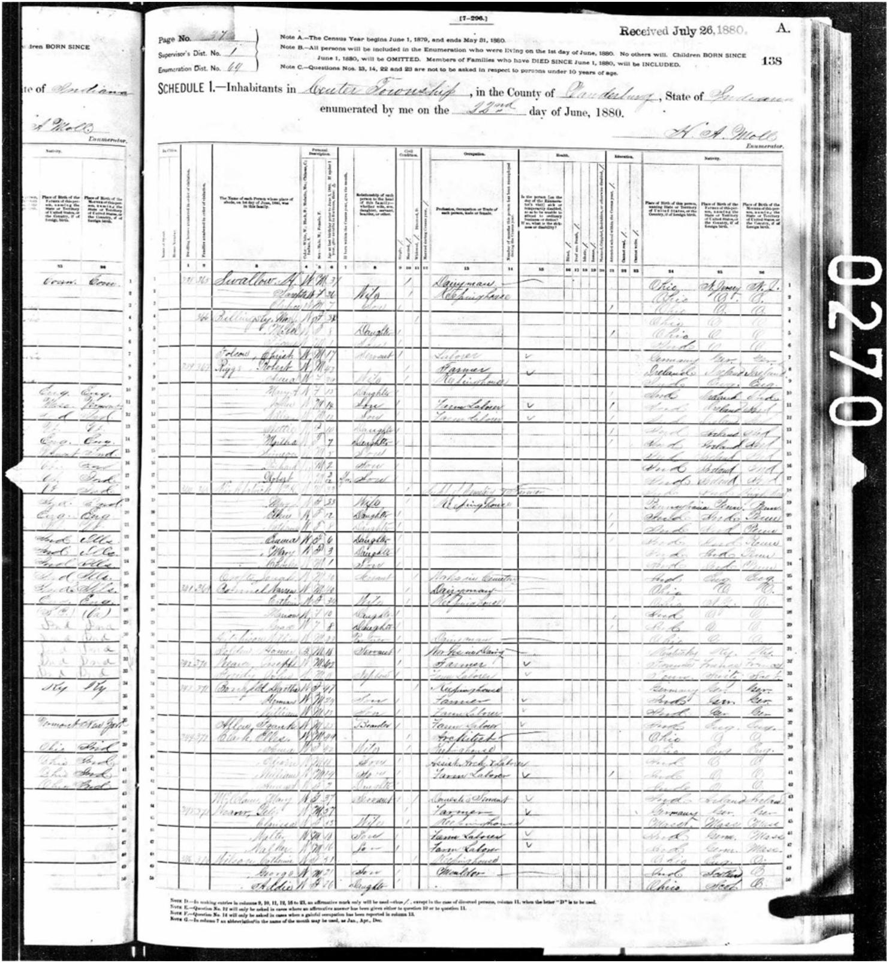

Report for the Francis Hutchinson Family | William Hutchinson | 12 April 2026
Exhibit 7a – Will of William Hutchinson (1894) pg 1
William Hutchinson will (1894), Vanderburgh County, Indiana, Will Records, vol. F–H, 1892–
1902; pages 65–66; will dated 2 August 1894, probated November 1894; digital image,
Ancestry.com (Indiana, U.S., Wills and Probate Records, 1798–1999,
https://www.ancestry.com/imageviewer/collections/9045/images/1479643-
00199?pId=1550247 : accessed 26 January 2026); citing original records of Indiana county,
district, and probate courts.
Copyright © 2026 Nancy E. Meade | nancyemeade@gmail.com
Page 20 of 23
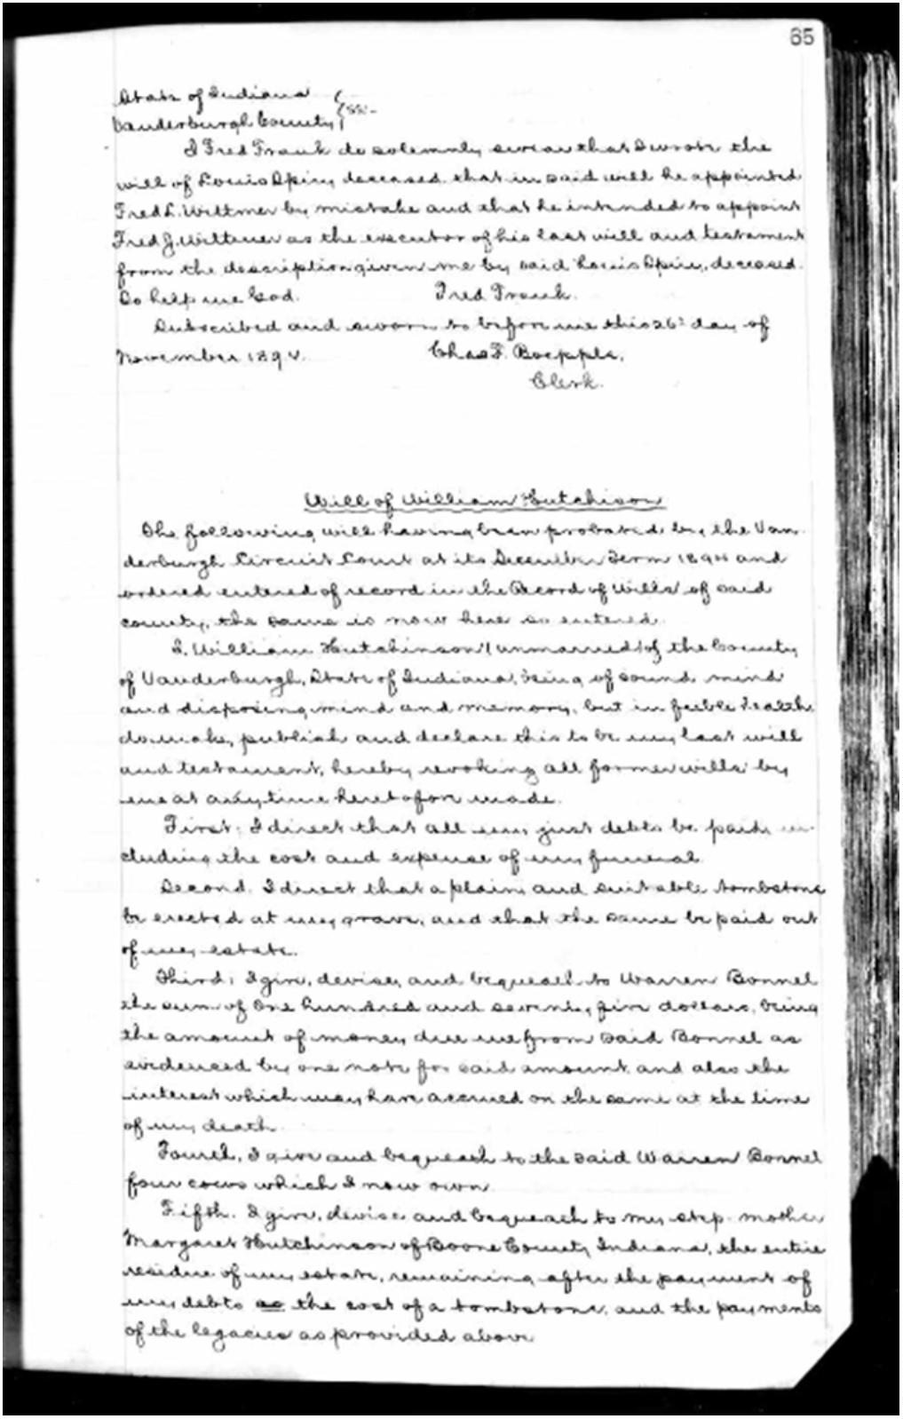

Report for the Francis Hutchinson Family | William Hutchinson | 12 April 2026
Exhibit 7b – Will of William Hutchinson (1894) pg 2
Copyright © 2026 Nancy E. Meade | nancyemeade@gmail.com
Page 21 of 23
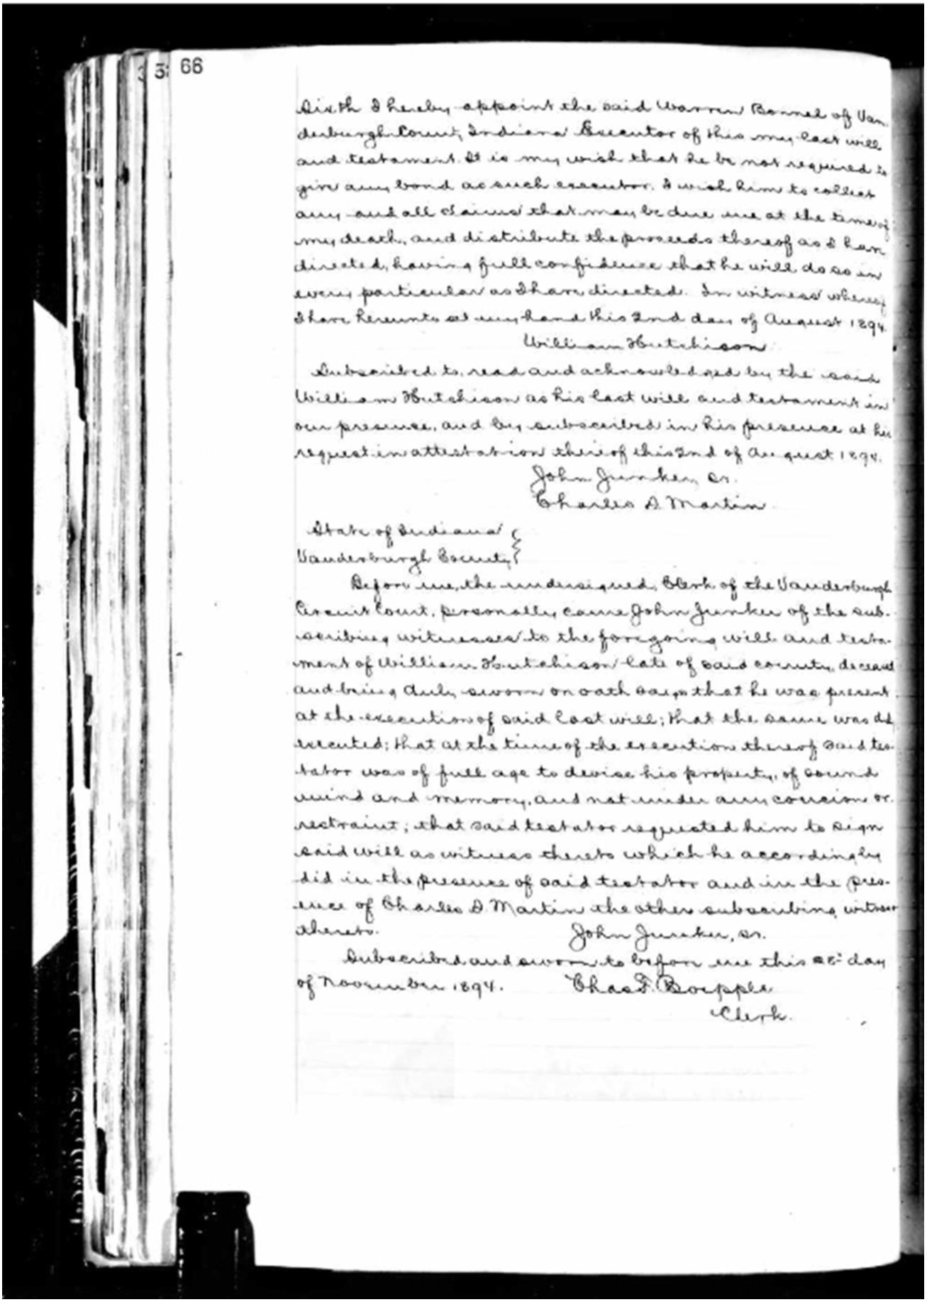

Report for the Francis Hutchinson Family | William Hutchinson | 12 April 2026
Transcription of William Hutchinson’s Will
Will of William Hutchinson
The following will having been probated by the Van-
derburgh Circuit Court at its December Term 1894 and
ordered entered of record in the Record of Wills of said
county, the same is now here so entered.
I, William Hutchinson (unmarried) of the County
of Vanderburgh, State of Indiana, being of sound mind
and disposing mind and memory, but in feeble health,
do make, publish and declare this to be my last will
and testament, hereby revoking all former wills by
me at anytime heretofore made.
First: I direct that all my just debts be paid, in-
cluding the cost and expense of my funeral.
Second: I direct that a plain, and suitable tombstone
be erected at my grave, and that the same be paid out
of my estate.
Third: I give, devise, and bequeath to Warren Bonnel
The sum of one hundred and seventy five dollars, being
The amount of money due me from said Bonnel as
evidenced by one note for said amount, and also the
interest which may have accrued on the same at the time
of my death.
Fourth: I give and bequeath to the said Warren Bonnel
four cows which I now own.
Fifth: I give, devise and bequeath to my step-mother
Margaret Hutchinson of Boone County Indiana, the entire
residue of my estate, remaining after the payment of
my debts the cost of a tombstone , and the payments
of the legacies provided above.
Sixth: I hereby appoint the said Warren Bonnel of Van-
Derburgh County Indiana Executor of this my last will
And testament. It is my wish that he be not required to
Give any bond as such executor. I wish him to collect
Copyright © 2026 Nancy E. Meade | nancyemeade@gmail.com
Page 22 of 23

Report for the Francis Hutchinson Family | William Hutchinson | 12 April 2026
any and all claims that may be due me at the time of
My death, and distribute the proceeds thereof as I have
directed, having full confidence that he will do so in
every particular as I have directed. In witness whereof
I have hereunto set my hand this 2nd day of August 1894.
William Hutchison
Subscribed to, read and acknowledged by the said
William Hutchison as his last will and testament in
Our presence, and by subscribed in his presence at his
Request in attestation thereof this 2nd of August 1894.
John Junker Sr.
Charles S. Martin
State of Indiana
Vanderburgh County
Before me, the undersigned, Clerk of the Vanderburgh
Circuit Court, personally came John Junder of the sub-
scribing witnesses to the foregoing will and testa-
ment of William Hutchison late of said county, deceased
and being duly sword on oath says that he was present
at the execution of said last will; that the same was duly
executed; that at the time of the execution thereof said tes-
tator was of full age to devise his property, of sound
mind and memory, and not under any coercion or
restraint; that said testator requested him to sign
said will as witness thereto which accordingly
did in the presence of said testator and in the pres-
ence of Charles S. Martin the other subscribing witness
thereto.
John Junker, Sr.
Subscribed and sworn to before me this 28th day
of November 1894.
Chas F. Boepple
Clerk
Copyright © 2026 Nancy E. Meade | nancyemeade@gmail.com
Page 23 of 23

